Problem Set 3
(100 points)

AI tools policy for problem sets: For problem sets, you may use AI tools (e.g. ChatGPT) to help brainstorm or to revise existing work you have written. When you submit your problem set, we expect you to clearly attribute what text was generated by the AI tool (e.g., AI-generated text appears in a different colored font, quoted directly in the text, or use an in-text parenthetical citation). While AI tools can provide helpful insights, we want you to think critically about the information you receive. We encourage you to ask specific questions, provide context, and evaluate the quality of the answers provided by AI tools. Remember, the answers are not always correct.

Problem 1. Tulip Production (15 points).
A firm uses fertilizer, labor, and greenhouses as inputs to produce tulips. When the quantity of labor and greenhouses is held fixed, the relationship between the quantity of fertilizer and the number of tulips produced is given by the following graph:
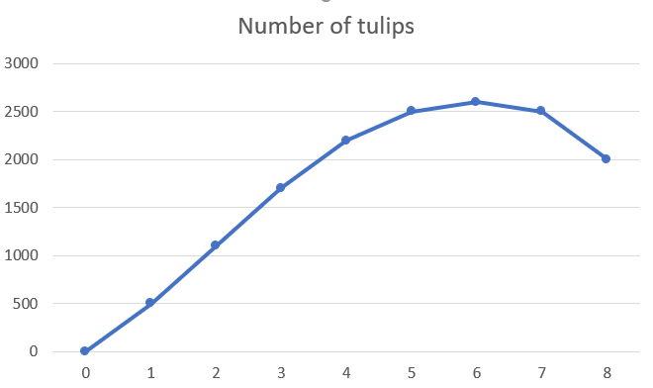

Tons of fertilizer

- (10 points) Compute the marginal product of fertilizer for the different fertilizer quantities and plot the marginal product of fertilizer as a function of the quantity of fertilizer. Remember to use the initial point as reference (e.g., the marginal product of moving from 3 to 4 tons should be entered at the initial point of 3 tons).

- (3 points) Does the production function exhibit diminishing marginal returns to fertilizer? If so, over which range of fertilizer quantity do they occur?

- (2 points) Does total output always increase as more fertilizer is added?

Problem 2. Sludge Production (15 points).
A bottling company uses two inputs to produce bottles of the soft drink Sludge: bottling machines (K) and workers (L). The machine costs $1,000 per day to operate and the workers earn $200 per day. At the current level of production, the marginal product of the machines is an additional 200 bottles per day and the marginal product of labor is 50 more bottles per day.
- (8 points) Is this firm producing its output in an optimized way? If so, say why. If not, explain in which direction the firm should change its quantity of machines and workers to optimize its production.
- (7 points) How does this relate to the idea of “bang for the buck” that we saw in class? Briefly illustrate in a short paragraph this concept with an example from your own experience/industry (no need to use actual numbers or real facts, you can use hypothetical scenarios if you wish).

Problem 3. Baseball Bats (25 points)
The cost data for a firm producing baseball bats appear below. Of the total cost, $25,600 is fixed at all levels of output. The bats sell for $6.40 each (we assume that the firm is a price taker).

Output | Total Cost | TFC | TVC | AFC | AVC | ATC | MC | TR | MR | Profit
0 | 25600
1000 | 31360
2000 | 35920
3000 | 39520
4000 | 42400
5000 | 44800
6000 | 46960
7000 | 49120
8000 | 51520
9000 | 54400
10000 | 58000
11000 | 62560
12000 | 68320
13000 | 75520
14000 | 84400
15000 | 95200
16000 | 108160

- (10 points) Fill out the above table, by entering the values of the following series: TFC, TVC, TC, AFC, AVC, ATC, MC, TR, MR, and profit. Remember to use the initial point as reference (e.g., the marginal cost of moving from 0 to 1,000 should be entered at the initial point of 0). You may copy the table to Excel or similar software and compute all values there.

- (5 points) Assuming that production can only be adjusted in steps of 1,000, what is the optimal output and what is the level of profits at this output level? If you could instead adjust quantity in smaller steps, would you produce (slightly) more or less in order to further raise profits (based on the comparison of MR and MC at the optimal output level you just reported)?

- (10 points) Assume that the market price drops to $5.50. What is the new optimal level of output? Does the firm make a loss or a profit? Should the firm continue to produce in the short run at this new price? Continue to assume that production can only be adjusted in steps of 1,000.

Problem 4. Basketball Production (30 points)
Balding is a Basketball producing firm that has seen better days. Its technology is old and expensive. Total costs of the old basketball-producing technology are given by
$TC_{o}=50+2Q+0.5Q^{2}$,
where Q is balls produced per hour.
The Balding managers are thinking about investment in a new technology. Total costs would then be given by:
$$TC_{N}=100+0.1Q^{2}$$
Balding is producing for the low-quality end of the market, and its basketballs are undifferentiated. This market is perfectly competitive and the typical market price for a ball is $10.

- (8 points) Under the old technology, what is the profit-maximizing output of Balding? What are profits at this output? Please explain how you obtained the profit-maximizing output and why following those steps makes sense. Here we want to know if you understand the concepts you apply, so avoid just solving a formula.

- (3 points) Illustrate your answer to a) graphically. Show the point at which profit is maximized under the old technology, and the area representing the profits at the profit-maximizing output. You do not need to plot the exact functions; an illustration is fine. Just make sure to include all the relevant curves and to get their shape right. You may use AI tools to produce graphs.

- (8 points) If Balding cannot avoid paying the fixed cost of the old technology, should it continue to produce basketballs?

- (8 points) If Balding operated only the new technology, what would be the optimal output, and what would be its profits?

- (3 points) Illustrate your answer to d) graphically. Show the point at which profit is maximized under the new technology, and the area representing the profits at the profit-maximizing output. You do not need to plot the exact functions; an illustration is fine. Just make sure to include all the relevant curves and to get their shape right. You may use AI tools to produce graphs.

Problem 5. Taxing sugary drinks (25 points)

You are working in the campaign team of the governor of California. The governor would like to implement a tax on sugary drinks. You are asked the following:
- (10) What should be the amount of the tax (per ounce)? Try your best to make a recommendation. There is no right or wrong answer. We want to evaluate your reasoning based on the economic concepts learned in class. If you want more background on taxing sugary drink you can have a look at this article. You are encouraged to use your own experience/knowledge or use other references to (online) sources.

- (8) Assume that the tax is levied on producers. How will the tax affect the equilibrium price of sugary drinks on the market? Illustrate your answer using a supply demand graph. You may use AI tools to produce graphs.

- (7) Who is more likely to bear the burden of the tax (and have the highest probability to vote for the governor’s opponent in the next elections)? How would your answer change if the tax is levied on consumers instead?

